**A MINI-PROJECT REPORT ON**

**“Vehicle Speed Limit Management System”**

SUBMITTED TO SAVITRIBAI PHULE PUNE UNIVERSITY, PUNE

IN THE PARTIAL FULFILLMENT OF THE REQUIREMENTS

FOR THE AWARD OF THE DEGREE

**Bachelor of Engineering**

In

**Information Technology**

##### Class: S.E

##### BY

**Name: Tanmay Borse Roll No.: S-006**

**Exam Seat: S191028510**

**Under the guidance**

Prof. Jaitee Bankar



**DEPARTMENT OF INFORMATION TECHNOLOGY**

**RMD SINHGAD SCHOOL OF ENGINEERING**

WARJE, PUNE-411058

## **A.Y: 2020 - 21**



**DEPARTMENT OF INFORMATION TECHNOLOGY**

**RMD SINHGAD SCHOOL OF ENGINEERING**

WARJE, PUNE-411058

**CERTIFICATE**

This is to certify that the Mini-Project Report entitled

**“VEHICLE SPEED LIMIT MANAGEMENT SYSTEM”**

Submitted by

Name: Tanmay Borse Roll No./Exam Seat No. : S191028510

is a bonafide work carried out by him/her under the supervision of Prof. Jaitee Bankar and it is submitted towards the partial fulfillment of the requirement for S.E (Information Technology) – 2019 course of Savitribai Phule Pune University, Pune in the academic year 2020-2021.

**(Ms. Jaitee Bankar)** **(Prof. Sweta Kale)**

Guide Head,

Department of Information Technology Department of Information Technology

(12, Sentence case)

**(Dr. V.V. Dixit)**

Principal,

RMD Sinhgad School of Engineering Pune – 58

Place:

Date:

**ACKNOWLEDGEMENT**

It is great pleasure for me to undertake this project. I feel highly doing the project entitled - **"Vehicle Speed Limit Management"**.

I would like to thanks **Prof. Sweta Kale** Head of IT Department for always positive approach and inspired us for project.

I am grateful to my project guide **Prof. Jaitee Bankar** Faculty Admin. This project would not have completed without their enormous help at every stage of project and worthy experience DBMS field.

Last but not least I am thankful to my almighty group members for their contribution and presence for project making and completion. Although this report has been prepared with utmost care and deep routed interest.

***TANMAY BORSE***

**Table of Content**

|  |  |  |
| --- | --- | --- |
| **Sr. No.** | **Content** | **Page No.** |
| **1.** | Abstract | 5 |
| **2.** | Introduction | 6 |
| **3.** | Data types | 8 |
| **4.** | Data Requirements  *4.1 Requirement collection and analysis*  *4.2 Entities*  *4.3 Attributes*  *4.4 Relationship - cardinality* | 9 |
| **5.** | ER Diagram | 11 |
| **6.** | Schema Diagram | 12 |
| **7.** | Relational Database Design | 13 |
| **8.** | Creating database using MySQL | 14 |
| **9.** | Test case queries | 16 |
| **10.** | Conclusion | 20 |
| **11.** | References | 21 |

**Abstract:**

This report represent database management of vehicle speed limit over ruled vehicles information and owners data. Speed detecting apps or techniques use by traffic control department capture the photo of vehicle and textual data can be stored on SQL database.

**INTRODUCTION**

A database management system (DBMS) refers to the technology for creating and managing databases. Basically DBMS is a software tool to organize (create, retrieve, update and manage) data in a database.

***The main aim of a DBMS is to supply a way to store up and retrieve database information that is both convenient and efficient***. Hence our primary goal is store the data and monitor it and perform various operation on it. By data, we mean known facts that can be recorded and that have embedded meaning.

Data of particular can be gathered by RTO office database if we have vehicle number plate picture.

The project is aim at computerizing the manual process of fine collection of speed limit overruled vehicles on highways or roads from owner by sending penalty on their homes.

So basically there are some pathway or segments were vehicles have some speed limit to avoid the accident on roads. Area such as near villages, hospital, schooling areas. But some time people overruled the speed limit so their need a traffic police officer in collect penalty from car owner or bike rider. But this process is manually. Here we try to make their job easy and safe. Also there should need easily view notice board or sign for drivers so they carefully attention of speed limit ahead.

**Problem Statement:**

Designing and implementing a vehicle speed limit database management system, containing data tables. Such as Detection for storing info getting from location where vehicle is passed.

**Motivation:**

Idea of the project came in mind when we saw traffic police officer stand on road/highways in any weather condition or we say extreme weather environment. Where they work in condition such as heavy rainfall to fiery summer seasons. So we think to make their work computerized that can be controlled from control rooms. It is time saving, easy to handle and implementation and stress decreasing way of service for them.

**Objective of Project:**

To achieve the easy way penalized system, the vehicle speed monitoring database management has following objectives:

* Research on current method of fine collection.
* Make penalty collection work easier and safer.
* Effective system for traffic control.
* A step for less accident or safe driving.
* Time saving system for traffic officers.

**Data Type:**

A data type as the name suggests is the type or category to which the data belongs to. It is an attribute of the data which defines the type of data an object can hold. In SQL the data type defines the type of data to be stored in each column of the table. Each column has its own data type. It is important to specify the data type of all columns so that similar values can be added to it. This means one column can hold only one type of data

Here we specified datatype of primary key of detection table, owner info Registration number as varchar of limit 25, primary key of address table and foreign key of owner info table Mobile number as int.

Datatype varchar is use in attributes like picture file name of limit 30, chassis number, vehicle class, fname and lname of limit 10 each, and also state name, chassis number. Address data table mostly we use varchar data type excluding street number which is in integer data type. Integer data type is use in vehicle speed. Location attribute declare in character datatype of limit 20.

Time datatype is use in attribute capture time of detection table. Vehicle registration date and owner’s date of birth (DOB) is declared in Date datatype.

**Data Requirements:**

1. Requirement Collections and analysis: (Minimum)

* Processor: Intel Pentium 4 with speed 2.50 GHz (MIN).
* RAM – 3 GB or more than 3 GB is required.
* CPU – 64-bit x 86 CPU is required (Min).
* Operating System – Windows 10.
* MySQL 8.0

1. Entity Types, Entity Sets:

* Entity: An object we want to model and store information about it. It is usually represented in Rectangles. In our project we have used 5 entities given as below:

Image File, Detection, Car details, Owner info, Address.

1. Attributes and keys:

|  |  |
| --- | --- |
| **Attributes** | **Keys** |
| Attributes are usually pieces of information about entity | Keys are usually an attribute that uniquely identify an entry in the database |
| It is denoted by ovals connected to entity. | There is total 7 types of keys |
| In our project we have used many attributes such as RC status, Registration Date etc. | In our project 2 types of keys are used  Primary key and Foreign key |

1. Relationships and cardinality:

* It is defined the number of instances of an entity from a relation that can be associated with the relation.
* There are 3 types Relationships Cardinality 1:1, N: M, 1: N we’ve used 1:N.

**ER Diagram:**

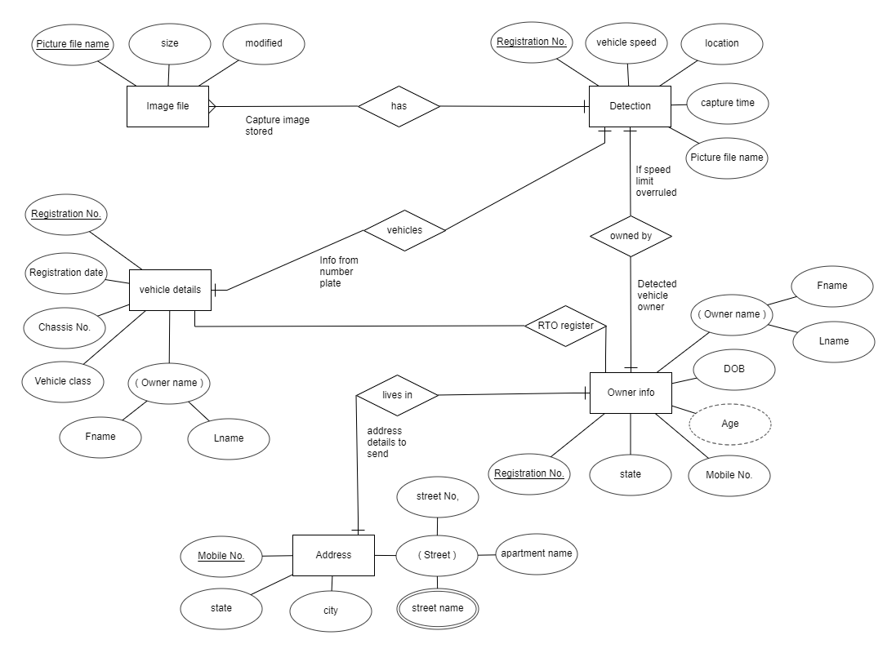

**Schema Diagram:**

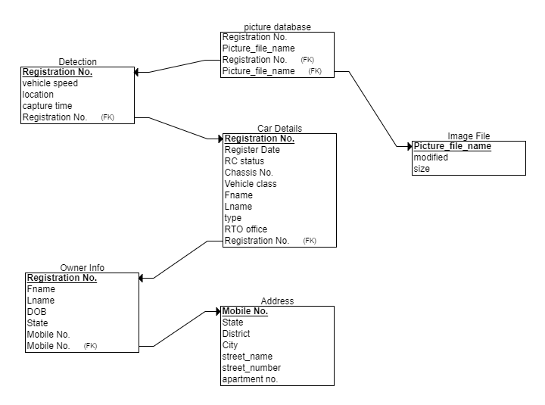

**Relational Database Design:**

As we see and observed from ER diagram we note that vehicle detection table is in one to many relation with image file table. It cleared us that many photos can be clicked of vehicle when it passes the location of image capturing. We note the Vehicle registration number by this information and proceed for further process.

Detection table is in one to one relation with car details and owner info table, as noted Vehicle of Registration number is owned by only one person and vehicle details are stored for particular vehicle is only one at registration time of vehicle. From car details and owner information table traced by Registration Number work as foreign key constraints in these both respective tables and primary key in Detection table we get owners as well vehicle details.

Owner info is in one to one relationship with owners address details. This clarify us at registration time owner register his permanent address in RTO office. So by this information we get address of vehicle owner to send penalty notice to his/her home. Here mobile number Owner information table works as foreign key in address table.

**Creating Data Base Using MySQL:**

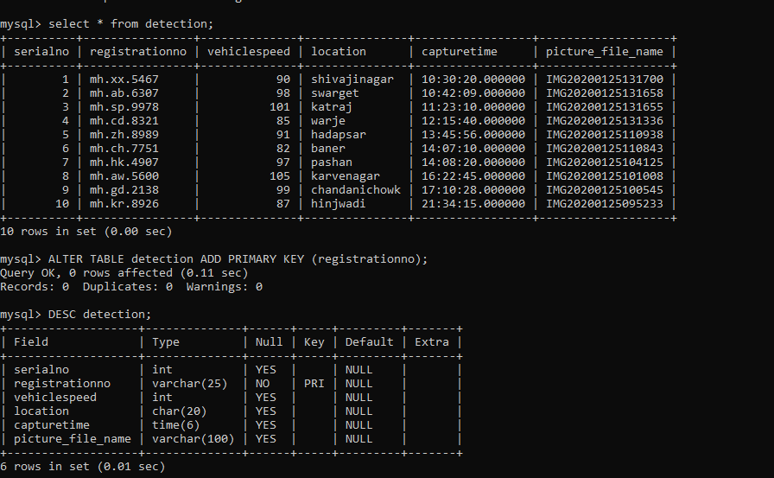

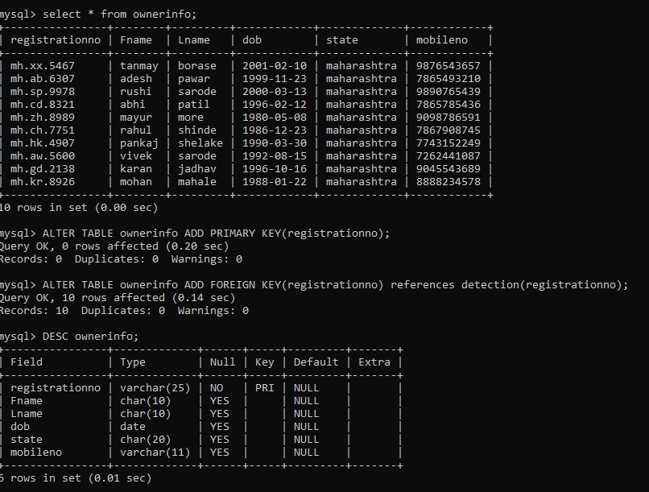

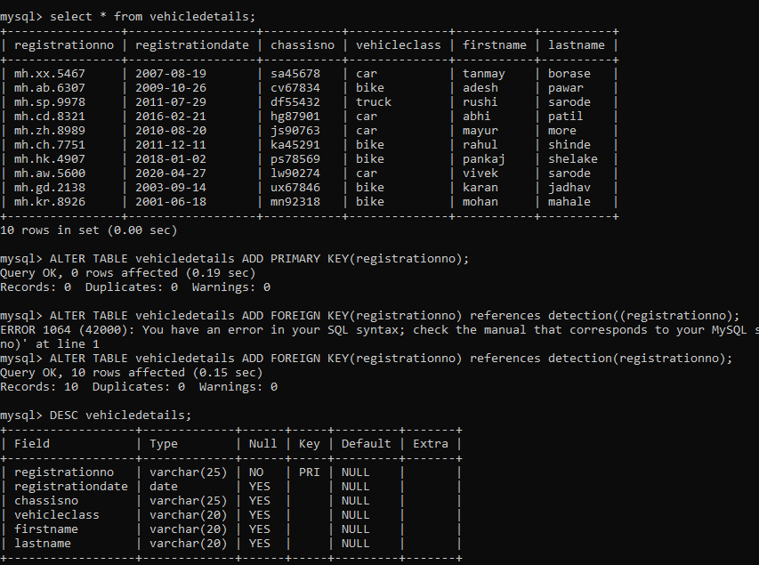

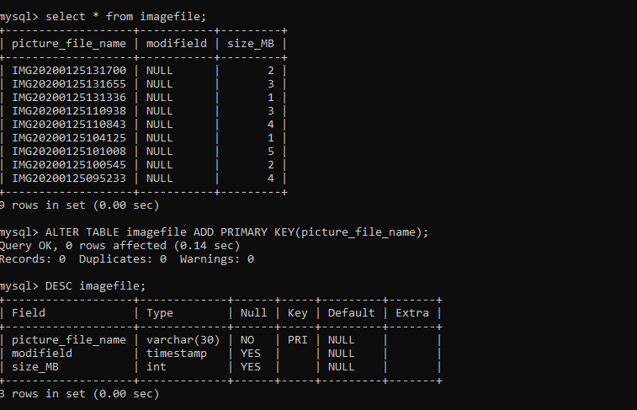

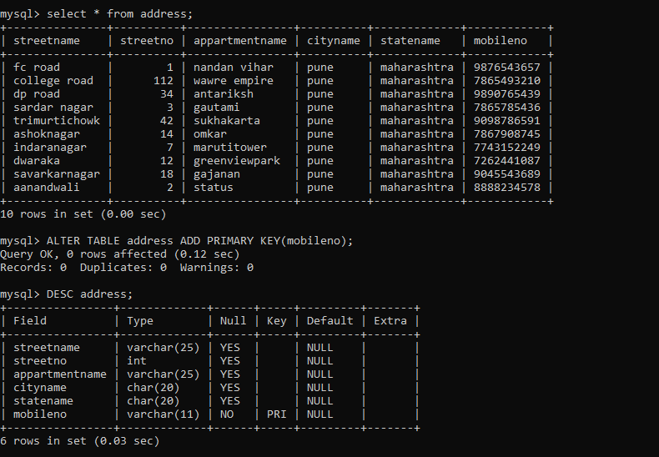

**Test Queries:**

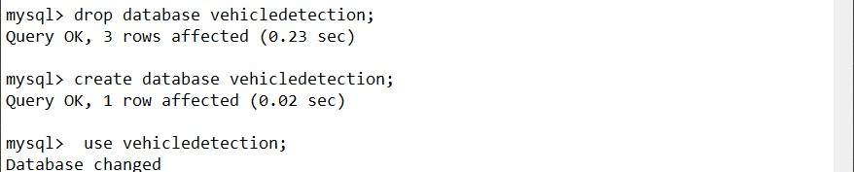

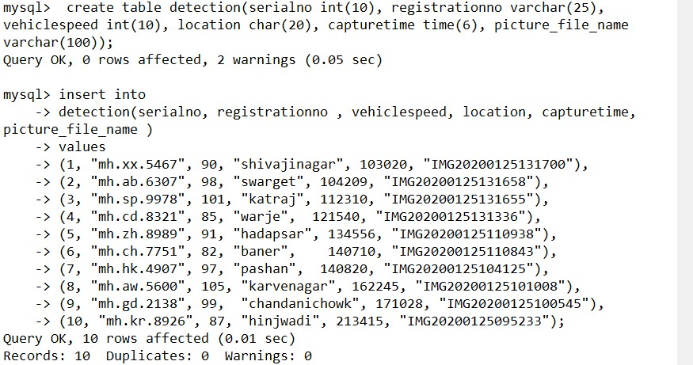

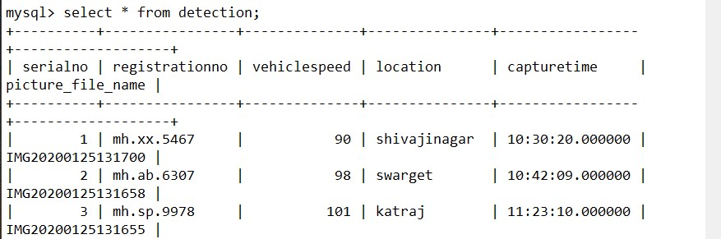



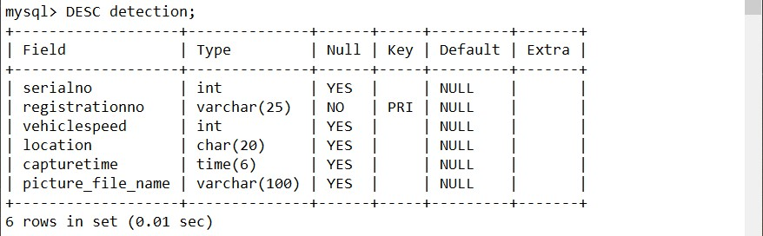

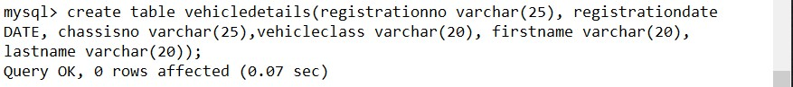

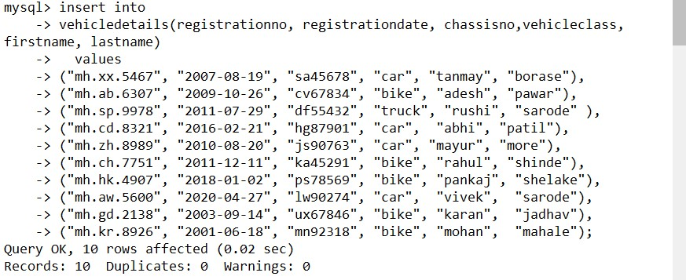

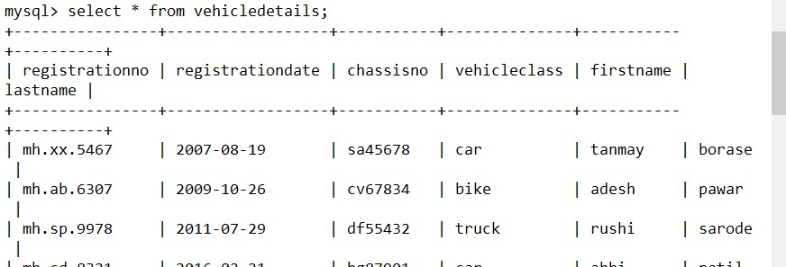



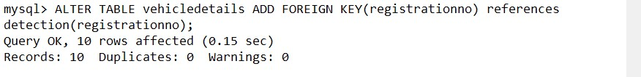

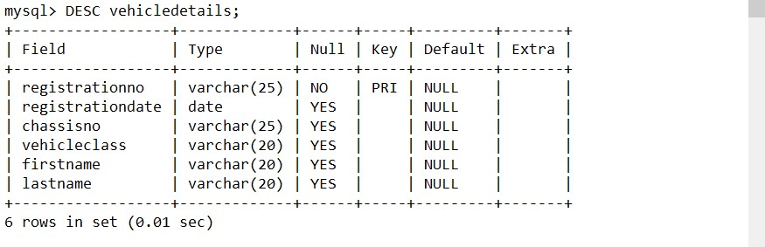



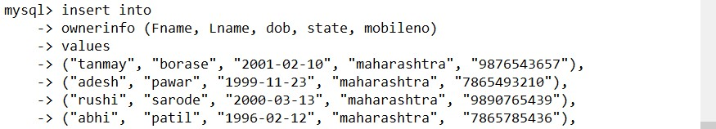











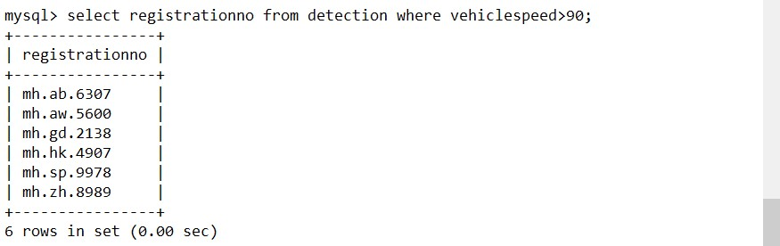

**Conclusion:**

In this project we have created one application which is easy to access and user friendly. The application keeps a backup of the driver’s data management data which includes their details. This system convert manual work to computer organized.

**References:**

* <https://app.creately.com/diagram/fHhd6xGmeYe/edit>
* <https://erdplus.com/standalone>
* <https://vahaninfos.com/vehicle-details-by-number-plate#:~:text=You%20can%20check%20following%20things,of%20vahan%2Fvehicle%20in%20India>.
* <https://en.wikipedia.org/wiki/Radar_speed_gun#:~:text=A%20radar%20speed%20gun%20(also,the%20speed%20of%20moving%20objects>.
* <https://www.nolo.com/legal-encyclopedia/free-books/beat-ticket-book/chapter6-1.html#:~:text=the%20pacer's%20observations.-,VASCAR,Speed%20Computer%20and%20Recorder%22>).